How to setup AWS EC2 Systems Manager and configure RunCommand on AWS Cloud

STEP 1:- Create a IAM Role and attach Policy.
--->Goto AWS Console-->Select Services-->Select IAM--> Left Side Select Roles--> Select
Create Role--->
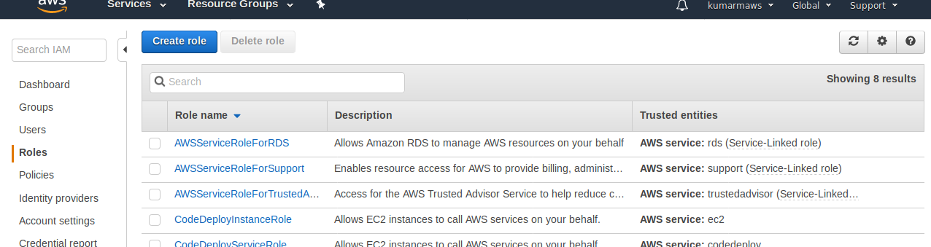
---> Select AWS Services --> Choose EC2---> Select Next:Permissions.
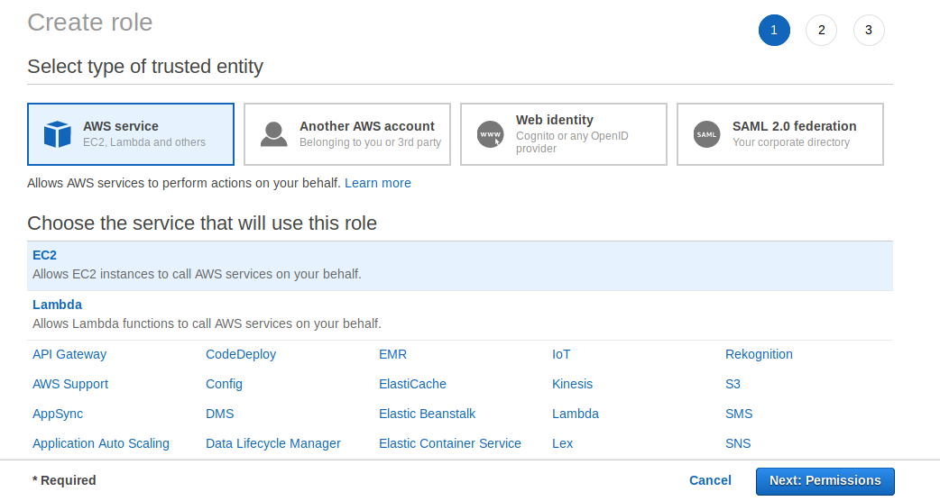
---> Select Existing Policy “AmazonSSMFullAccess” from filter policies--->

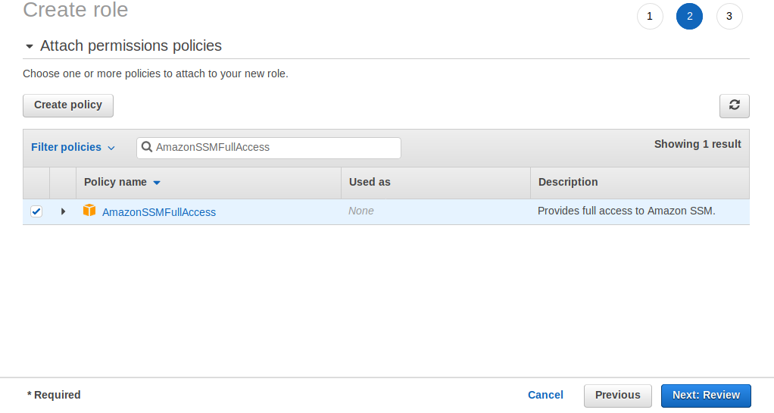
---> Select Review.
---> Next Give role name: MySSMrole-->
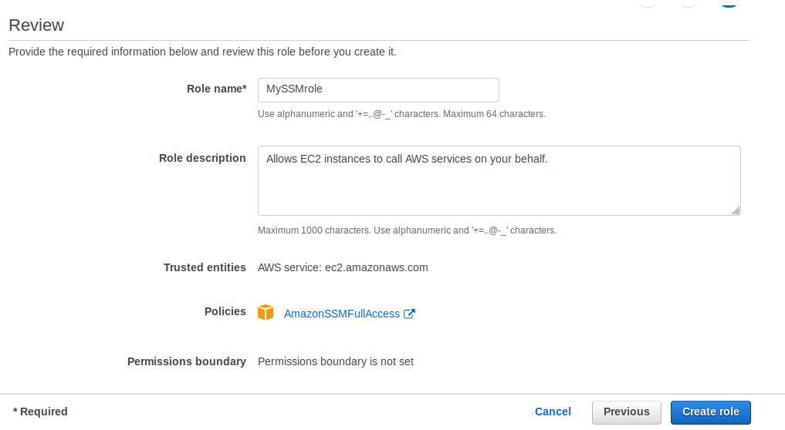
---> Select Create role-->

--> My SSM role created successfully.
---> If Click the role it will come like below,
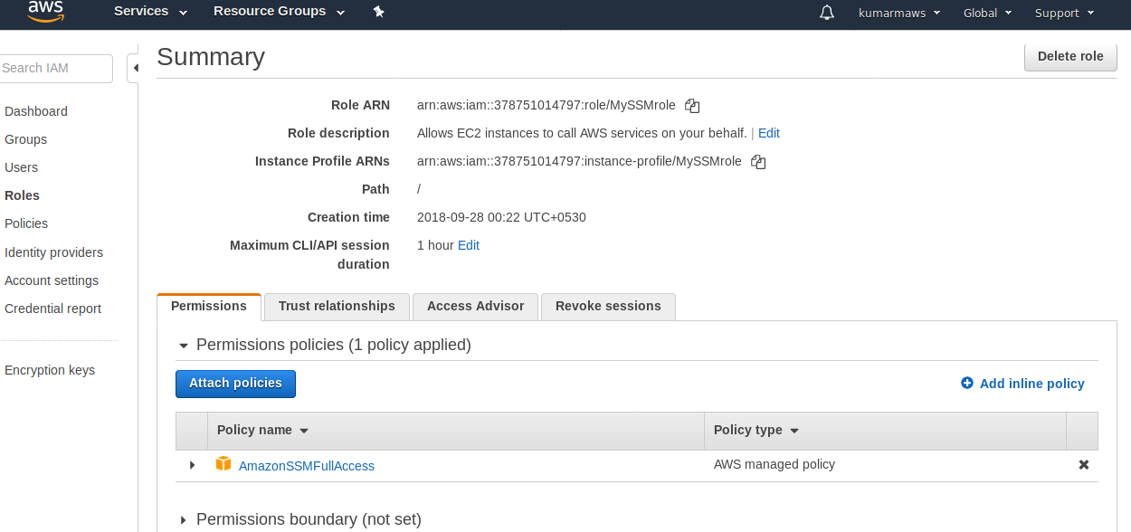
STEP 2:- First Create a Security Group for EC2-Instances.
--->Goto AWS Console-->Select Services-->Select EC2--> Select Security Group--> Select
Create Role---> Select Create Security Group-->
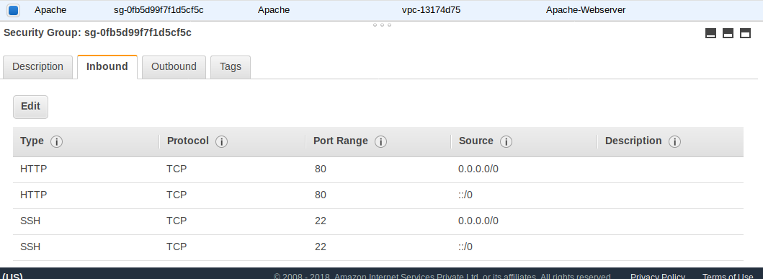
--->ssh-->22-->for remote connect.
-->http-->80-->for Apache

STEP 3:- Create EC2 Instances and attach existing Security Group and IAM (MySSMrole)
role.
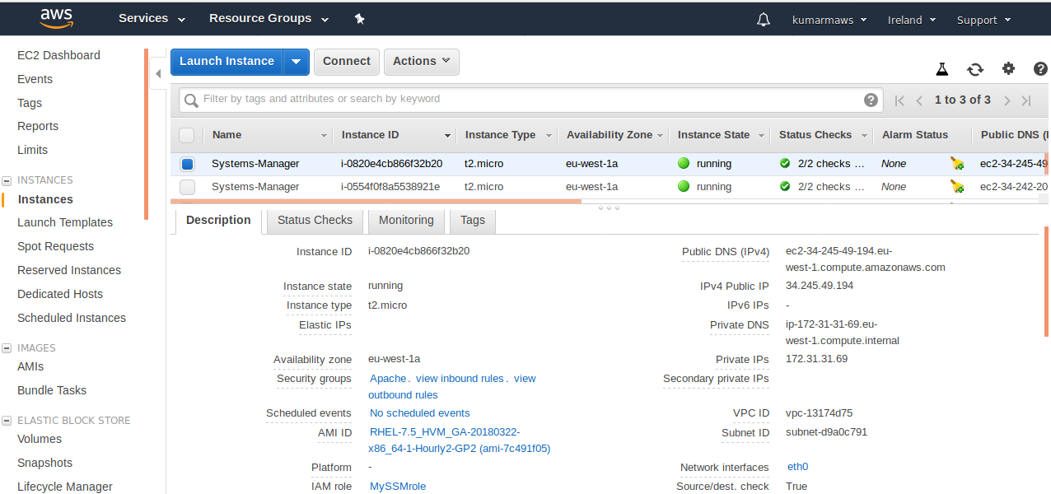
STEP 4:- Connect to EC2 instances and install SSM Agent on Red Hat Enterprise Linux.
---> Connect to EC2-Instance.
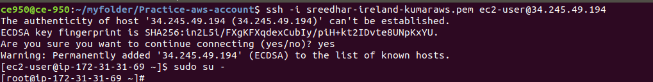
--->Install SSM Agent on Red Hat Enterprise Linux.
-->Use the following command to download and run the SSM Agent installer-->
sudo yum install -y https://s3.amazonaws.com/ec2-downloads-windows/SSMAgent/latest/linux_amd64/amazon-ssm-agent.rpm
--->Run one of the following commands to determine if SSM Agent is running. The command
should return the message "amazon-ssm-agent is running."
sudo systemctl status amazon-ssm-agent

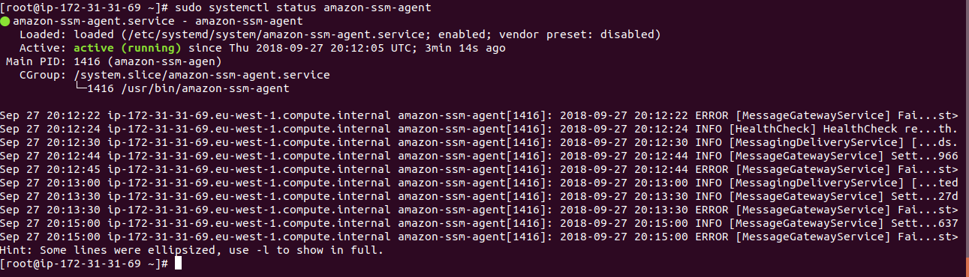
STEP 5:- Goto Systems Manager Services.
--->Goto AWS Console--> Select Services--> Select EC2-->left side panel goto
down---> Select Systems Manager Services--> Select Run Command-->
again Select Run Command---> it will goto Commad Document-->
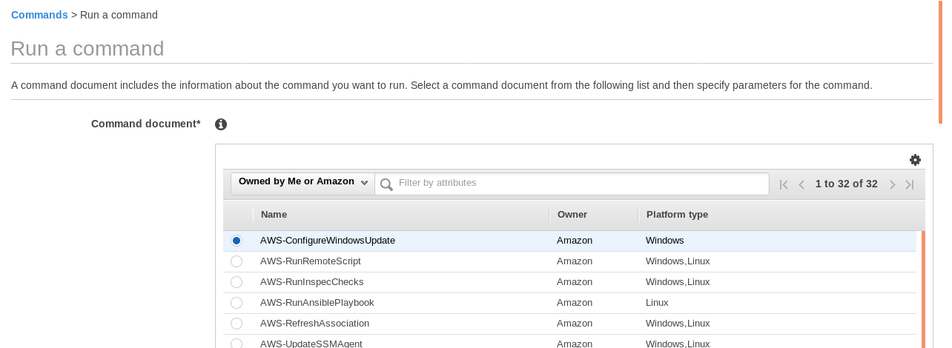
---> Here Selecting “AWS-RunShellScript” to run the shell commad.
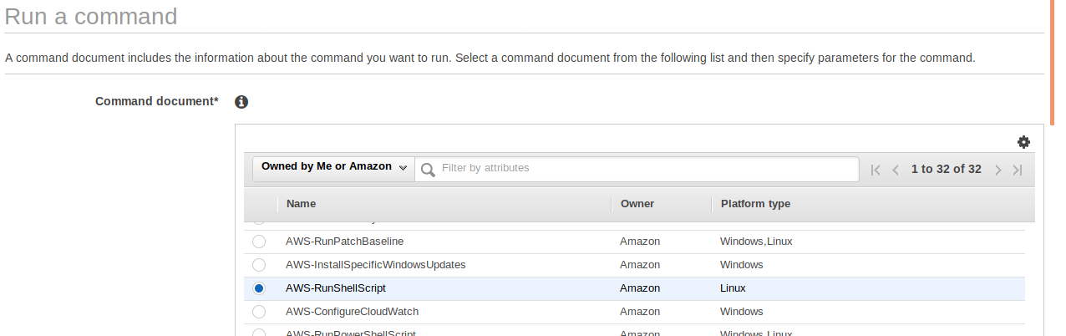
--> Come down it will come “Select Targets by*”

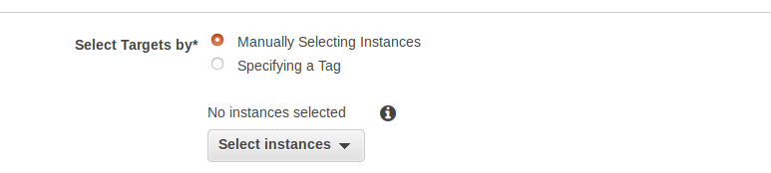
---> Choose Select Instances-->select instances(its visible only SSM agent installed servers (other wise its not visible))--->
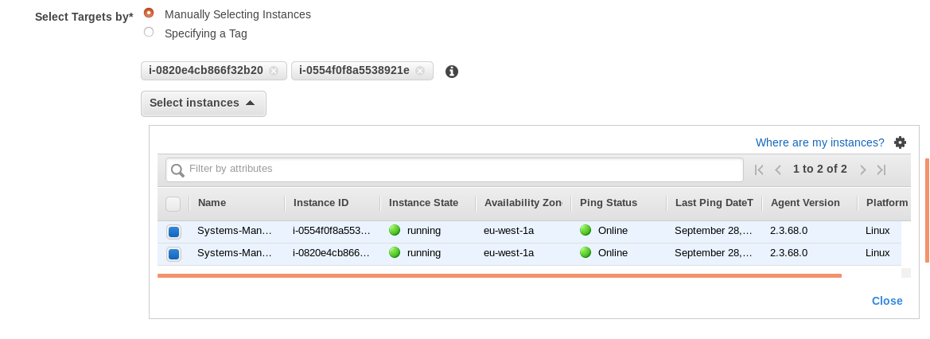
--->come down few more options will come--> Commands* Section give
whatever commands to execute in servers-->
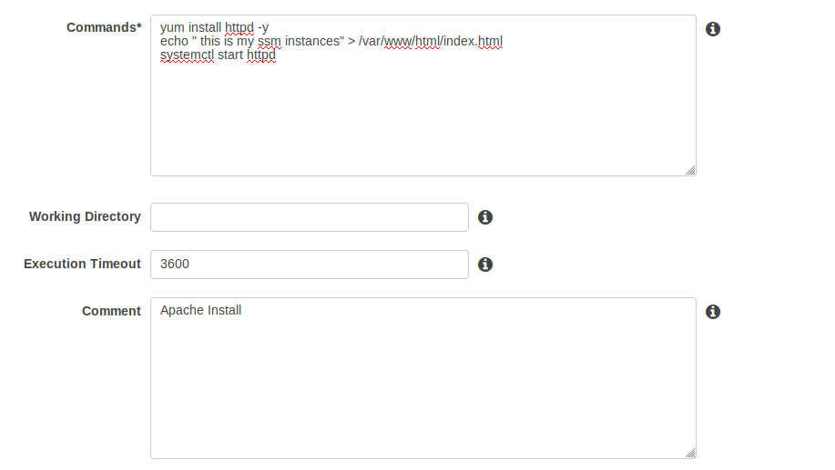

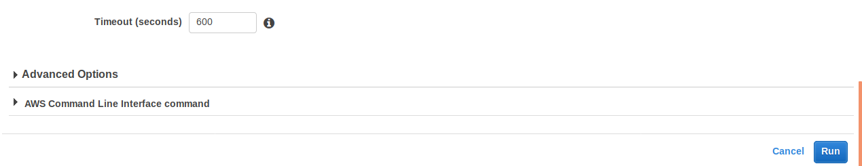
---> Select Run.
---> It will come like below-->
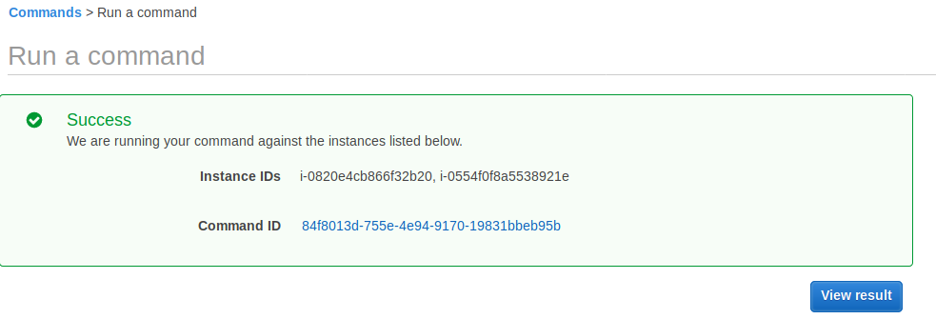
--->Select View result--> It will come like below,
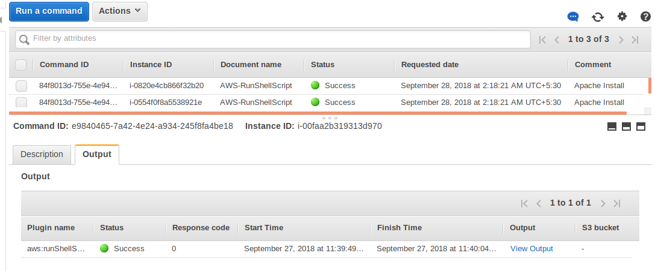
---> Select View Output. It will come like

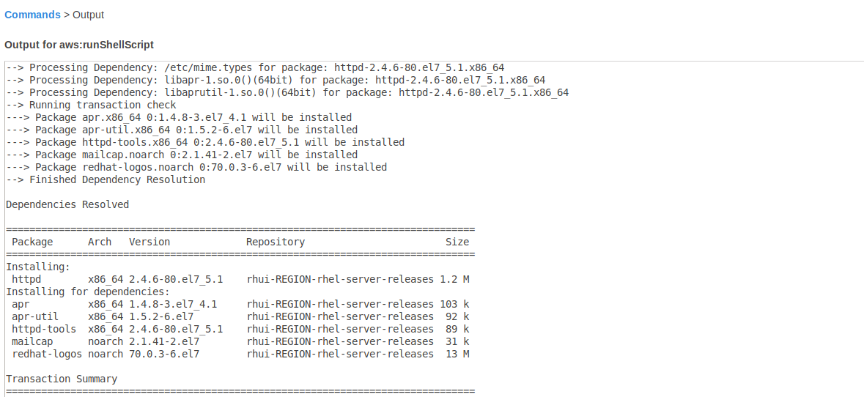
--->Select both Servers Public IP’s (34.245.49.194 ,34.242.201.22 )and Search in browser.
---> Result will come like below-->
---> Search with first server public IP ( 34.245.49.194)

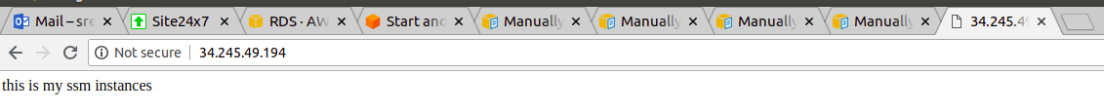
---> Search with second server public IP ( 34.242.201.22)

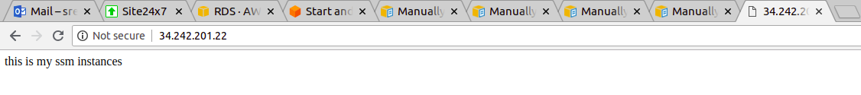

--->Both Servers executed same commands i.e same out put for both servers.

